6900 Planned GI date - Change report and orders.docx

**From:** Tran, Gia-My   
**Sent:** Tuesday, 09 January, 2018 3:02 PM  
**To:** Lee, Kar Mun; Chan, Pei-Fong; Phoen, Eugene  
**Cc:** SG-DistList-SIN-SonyMobile-Outbound; Low, Dennis  
**Subject:** RE: RU shipment report for Week 51 - Planned GI Date

Hi Pei Fong,

Could you add on one more column for Planned GI date in Loading Plan Report to let us easily follow up them

Also, could you assist to change Delivery Date to Planned GI date information due to we need it more

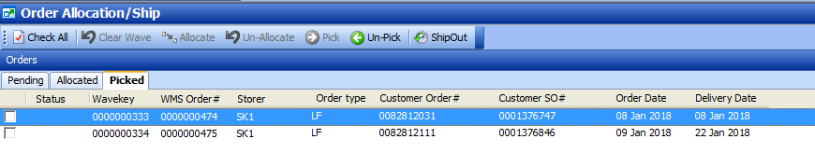

WMS changes-

1. Loading Plan Report - added GI Date

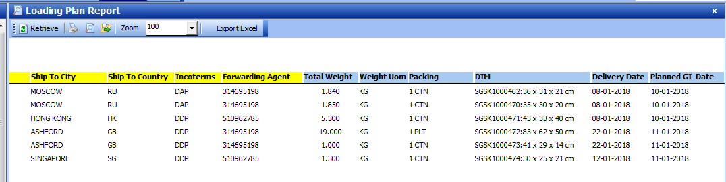

1. Order Allocation/Ship screen

Add Planned GI date, forwarder

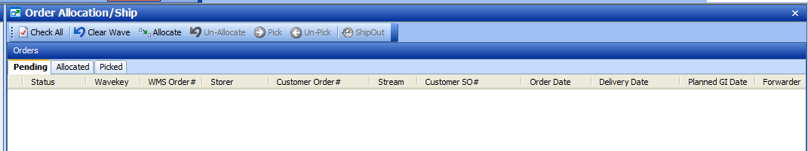

Picked tab

Add Planned GI date, forwarder

Packkey and Pack status

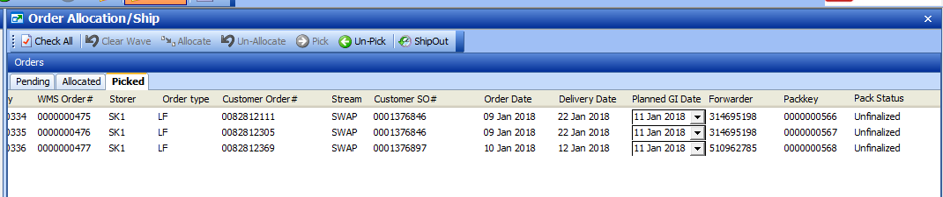

Ship validate – not allow ship if pack status is unfinalzed

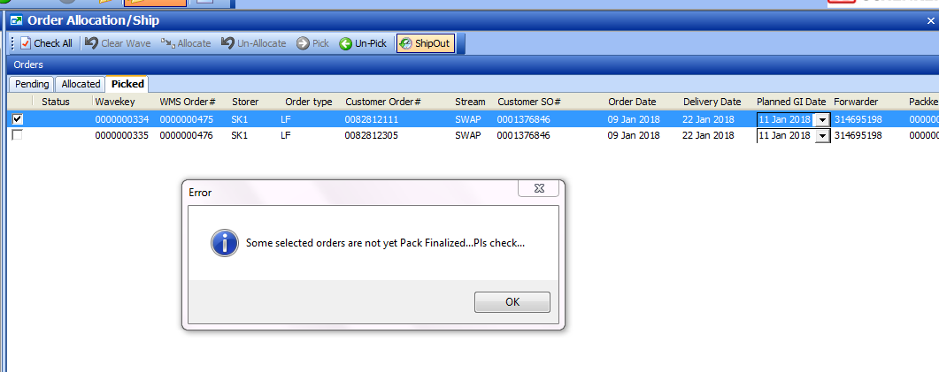

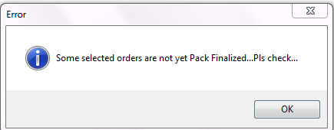

After finalize

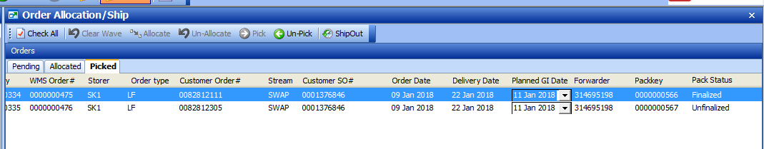

Allow to ship

